**Alert Watch and Response Engine (AWARE)**

Server Installation Guide



April 2014

Prepared by Harris Corporation

Revision History

| Creation Date | Version No. | Description/Comments | Author(s) | Reviewer(s) | Review Type | Issue Date |
| --- | --- | --- | --- | --- | --- | --- |
| 03/24/2014 | .0.01 | Initial | S. Beckham B. Jan |  |  | TBD |
|  |  |  |  |  |  |  |
|  |  |  |  |  |  |  |
|  |  |  |  |  |  |  |
|  |  |  |  |  |  |  |
|  |  |  |  |  |  |  |
|  |  |  |  |  |  |  |
|  |  |  |  |  |  |  |
|  |  |  |  |  |  |  |
|  |  |  |  |  |  |  |
|  |  |  |  |  |  |  |
|  |  |  |  |  |  |  |

Table of Contents

1 Purpose 1

2 Project Description 1

3 Installation 1

3.1 Hardware/Server 1

3.1.1 Security Accounts 1

3.1.2 Host Names and TCP/IP Addresses 1

3.1.3 Web Applications (Sites) 2

3.2 Reporting Services 1

3.2.1 Before You Begin 1

3.2.2 Installation Procedure 1

3.2.3 After the Installation 14

List of Tables

Table 1 - Web Applications (Sites) 2

Table 2 – Required Software 1

List of Figures

Figure 1 - UAC Dialog Box 1

Figure 2 – SQL Server Installation Center 2

Figure 3 - Processing the Current Operations 2

Figure 4 – Setup Support Rules 3

Figure 5 - Processing the Current Operations 3

Figure 6 - Setup Support Files 4

Figure 7 - Setup Support Rules 4

Figure 8 - Product Key 5

Figure 9 - License Terms 5

Figure 10 - Setup Role 6

Figure 11 - Feature Selection 6

Figure 12 - Installation Rules 7

Figure 13 - Instance Configuration 7

Figure 14 - Disk Space Requirements 8

Figure 15 - Server Configuration 8

Figure 16 - Database Engine Configuration 9

Figure 17 - Analysis Services Configuration 10

Figure 18 - Reporting Services Configuration 10

Figure 19 - Error Reporting 11

Figure 20 - Installation Configuration Rules 11

Figure 21 - Ready to Install 12

Figure 22 - Installation Progress 12

Figure 23 - Complete 13

Figure 24 - SQL Installation Center 13

Figure 25 - SQL Login 14

# Purpose

The purpose of this document is to provide the necessary information for Alert Watch and Response Engine (AWARE) server installation at Veterans Affairs (VA) facilities.

# Project Description

The Computerized Patient Record System (CPRS) View Alerts package delivers notification of non-life threatening critical test results; however, it does not track whether providers take appropriate follow-up actions in response to the alerts. Currently, the only way to track follow-up actions on critical alerts is through manual review of individual patient records. The innovation Alerts, Watch and Response Engine (AWARE) will track and monitor follow-up actions and will identify certain critical lab and imaging test result alerts that lack timely follow-up. AWARE also consists of a web-based knowledge base editor and a quality measures reporting tool.

# Installation

## Hardware/Server

For a successful deployment of the AWARE application, the following recommendations / requirements should be satisfied.

### Security Accounts

* Windows service account:
  + Required for executing the SQL Transporter Service
  + Required for the Application Pool for the QI Tool web application
  + Required for the pass thru authentication for the QI Tool web application
  + Required for the registration of application-specific DLL’s for the user context under which the application will execute.
  + Should have administrative role on the application server
  + Should not belong to any group/domain group that does not have the permissions to query for security tokens
  + Requires permissions to query the Active Directory for Authentication purposes
  + Requires permissions to query the Active Directory for individual group memberships
* MS SQL Server account:
  + Windows service account referenced above should be added to the SQL Logons list.
    - The logon should have the Public and Server Admin Server roles applied to it. These rights are granted after adding the logon from within MS SQL Server.

### Host Names and TCP/IP Addresses

All host names and TCP/IP addresses should be known to the installation personnel prior to installation.

### Web Applications (Sites)

The applications (sites) listed in Table 1 below should be created separately within IIS. Note the following:

* Each application should be its own IIS application.
* Each application should be bound to unique ports.
  + All ports used for each application should be open for both incoming and outgoing traffic from within VA firewall.

Table - Web Applications (Sites)

|  |  |
| --- | --- |
| **Application (Site)** | **Additional Notes/Requirements** |
| KBEditor |  |
| AlertCache |  |
| QITool | This application (site) needs an application pool identity configured. Identity should be the windows service account created above.  This site requires pass-through authentication configured. |

The hardware requirements, as the current AWARE solution is being developed against, are on a Windows 2008 R2 Server with MS SQL 2008 R2 Enterprise Edition, and running Internet Information Services (IIS) 7.5.

The installation of the software listed in

Table 2 exists on this server and must be installed on the target server as indicated.

Table – Required Software

|  |  |
| --- | --- |
| **Software** | **Additional Information/Requirements** |
| **Microsoft Windows 2008 R2 Service Pack 1**  Applies to the Application, Database, and IIS 7.x Web Servers. | Windows 2008 R2 Service Pack 1 may be downloaded from the following URL: <http://technet.microsoft.com/en-us/windowsserver/gg635126.aspx> |
| **Microsoft SQL Server 2008 Enterprise Edition R2**  Applies to the Database Server | SQL Server Reporting Services (SSRS) should be installed and configured under the same instance as SQL Server.  Reporting services port should be different than the Web Applications and be open.  Access to the SSRS configuration tool to configure reporting services.  Server collation should be SQL_Latin1_General_CP1_CI_AS.  Common Language Runtime needs to be enabled through the advanced options of SQL Server.  SQL Server authentication mode should be “Mixed Mode”  The port which SQL Server will be listening should not be blocked as the ancillary applications need read/write access:   * QI Tool * Alert Cache Viewer * KB Editor * Reporting Services |
| **Internet Information services 7.x (IIS 7.X) with the web server role and the web publishing service**  Applies to the Web Server | Microsoft .NET Framework 4.x  Applies to the Application, Database, and IIS 7.x Web Servers  Microsoft .Net 4 can be downloaded from the following URL: http://www.microsoft.com/en-us/download/details.aspx?id=17718  .NET 4.0 should be installed prior to configuring IIS  .NET 4.0 should be registered with IIS.  ISAPI & CGI Restrictions for ASP.Net 4.x should be allowed on the IIS Server.  .NET 4.5 for Microsoft .NET Framework 4 Update   * .NET 4.5 update can be downloaded from the following URL: <http://www.microsoft.com/en-us/download/details.aspx?id=30653>   Microsoft Report Viewer 2010 Redistributable Package.   * Microsoft Report Viewer 2010 Redistributable Package can be downloaded from the following URL: <http://www.microsoft.com/en-us/download/details.aspx?id=6442> * Must be installed after Microsoft .NET 4.5 is installed. * Must be installed on the server hosting the AWARE QI Tool website   The Report Viewer managed handler should be registered in IIS at the root level and set to accept all verbs. |
| **Cache Server** | Provide the Cache Server version  Provide Cache Server User with at least %Developer role  Provide VistA access from SQL Server  Provide user with programmer access |

On the two test sites, Visual Studio 2008 or 2010 (either one or the other) should be installed. It can be uninstalled after successful deployment.

It may be required to set up group administration of a shared folder on a Windows Server. This would allow access to AWARE components that need to be downloaded to local VA workstation(s) for test users of AWARE. These components would include an AWARE DLL which would subsequently need registering on a local work station(s).

Group administration of the shared folder would also be needed in order to allow specific users access to these components. The shared folder could also serve as a repository for support documentation for the workstations with AWARE components installed (e.g., for data recovery purposes).

## Reporting Services

### Before You Begin

Before performing this procedure, verify that there are no database files in the following location:  
C:\Program Files\Microsoft SQL Server\MSSQL10_50.MSSQLSERVER\MSSQL\DATA

If any files are located here, manually delete them. The installation will fail if any files are present at this location when the installation procedure begins.

### Installation Procedure

1. Double click setup.exe.  
   Setup is launched and the User Account Control (UAC) dialog box appears.

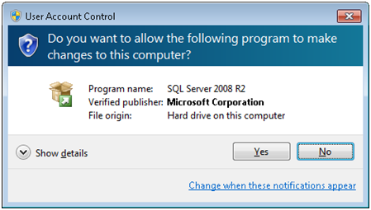

Figure - UAC Dialog Box

1. Click Yes.  
   The SQL Server Installation Center window appears.

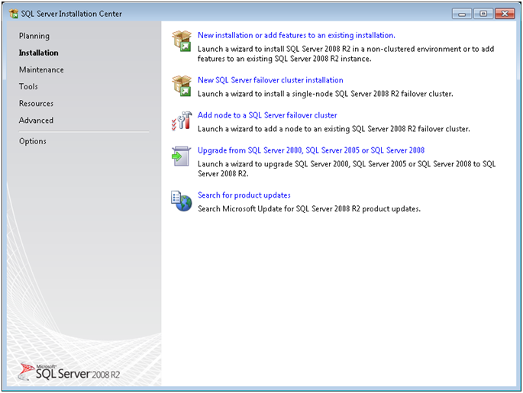

Figure – SQL Server Installation Center

1. Click Installation on the left pane of the SQL Server Installation Center window.
2. Choose “New installation or add features to an existing installation.”  
   The following message box appears, followed by the Setup Support Rules window (Figure 4)..

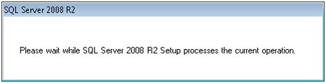

Figure - Processing the Current Operations

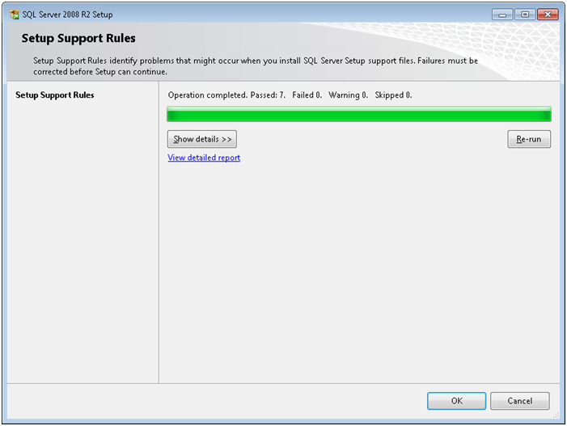

Figure – Setup Support Rules

1. Make sure no errors or warnings appear in the Setup Support Rules window (Figure 4).  
   **NOTE**: If any errors or warnings appear, resolve them before continuing with the next step in this procedure. Click Show Details for additional information.
2. Click OK if no errors or warnings appear in the Setup Support Rules window (Figure 4).  
   The following message box appears, followed by the Setup Support Files window (Figure 6).



Figure - Processing the Current Operations

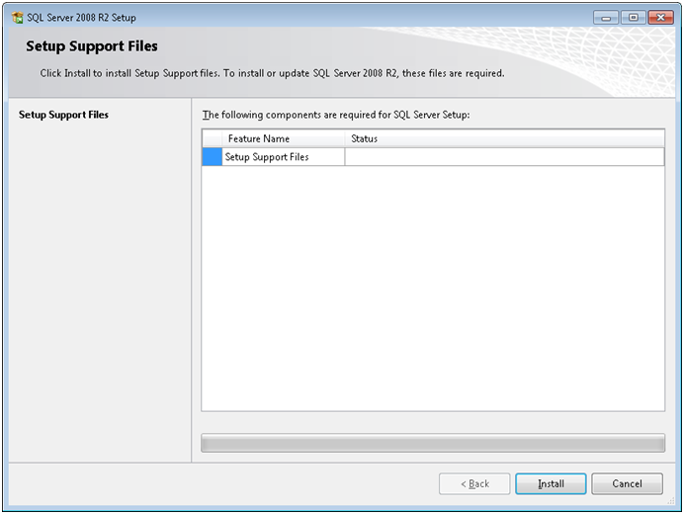

Figure - Setup Support Files

1. Click Install.  
   The operation is processed, and then the Setup Support Rules window appears (Figure 7).

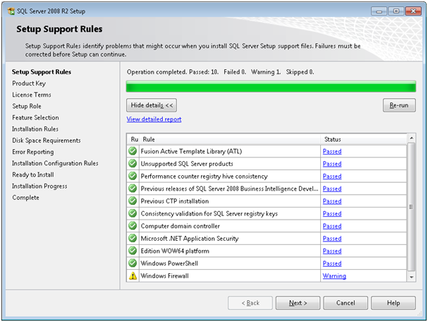

Figure - Setup Support Rules

1. Do one of the following:
   1. Click Next if your Setup Support Rules window appears similar to Figure 7 above.  
      **NOTE**: If a warning appears in the “Windows Firewall” row, you may continue this procedure. If any other warnings or errors appear, contact technical support personnel for help with resolving the issues before proceeding.
   2. Contact technical support personnel if any other warnings or errors appear. Do not proceed to step 9 until the issues are resolved.

The Product Key window appears.

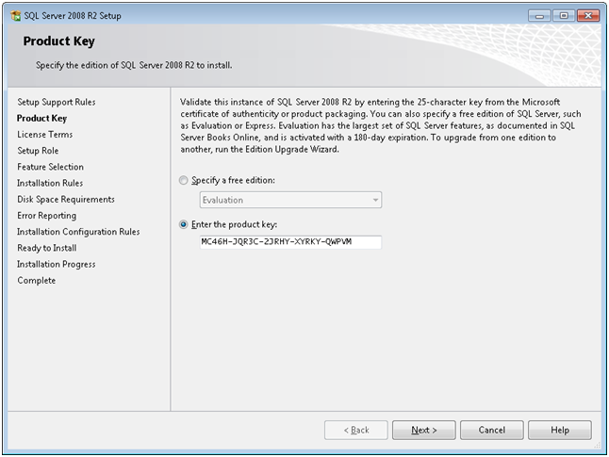

Figure - Product Key

1. Verify the Product Key is correct, correct it if needed, and then click Next.  
   The License Terms window appears.

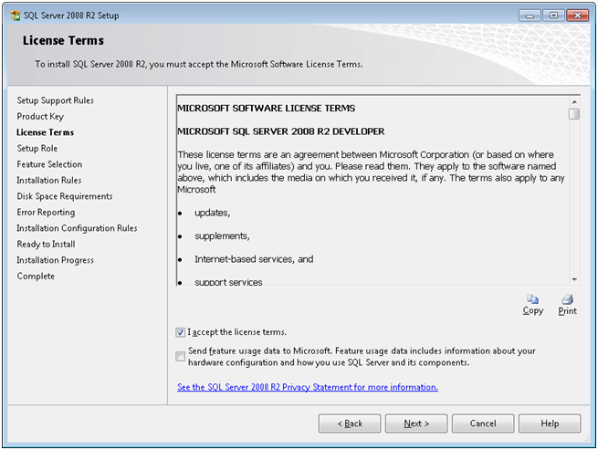

Figure - License Terms

1. Click the checkbox indicating “I accept the license terms” and then click Next.  
   The Setup Role window appears.

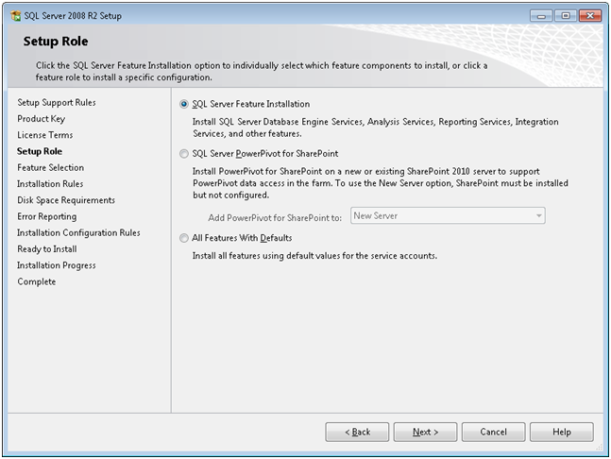

Figure - Setup Role

1. Make sure “SQL Server Feature Installation” is selected in the right pane, and then click Next.  
   The Feature Selection window appears.

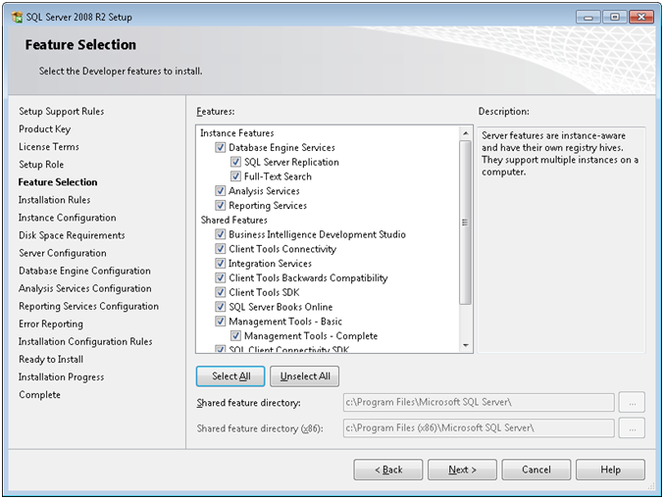

Figure - Feature Selection

1. Click Select All, and then click Next.  
   The Installation Rules window appears.

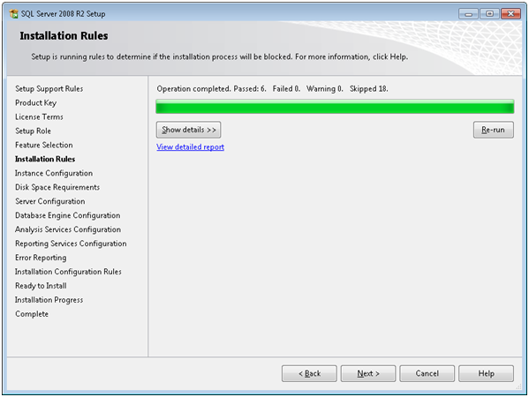

Figure - Installation Rules

1. Do one of the following:
   1. Click Next if no failures or skipped messages appear in the Installation Rules window.
   2. Click Show Details if any failures or skipped messages are shown, and contact technical support personnel if needed to help resolve the issues. Do not continue to step of this procedure until the issues are resolved.

**NOTE**: It is critical that the steps from this point forward be followed exactly as described in this procedure.

The Instance Configuration window appears.

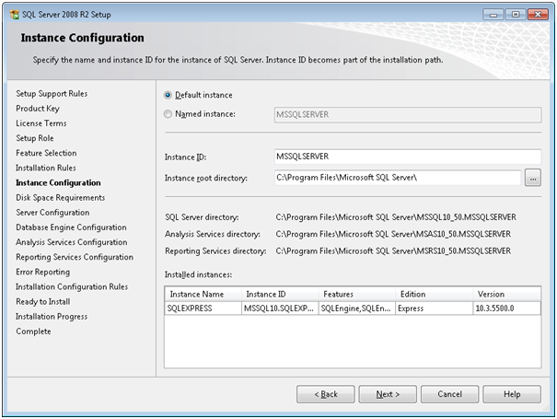

Figure - Instance Configuration

1. Make sure “Default Instance” is selected. Do not select “Named Instance,” which is selected by default!
2. Make sure the SQLEXPRESS instance is the ONLY instance that appears in the “Installed Instances” field. If it is not, discontinue this procedure and uninstall any other instance that appears before proceeding to step 16 of this procedure.
3. Click Next.  
   The Disk Space Requirements window appears.

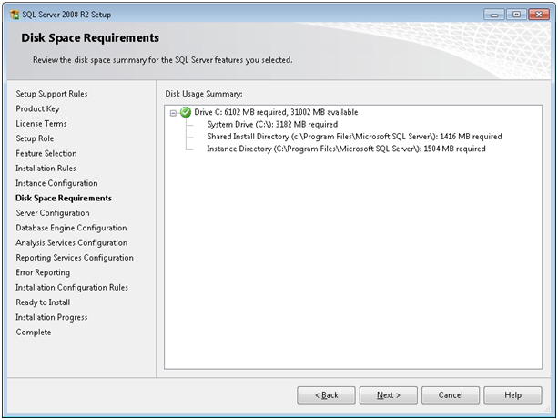

Figure - Disk Space Requirements

1. Click Next when a checkmark appears (as shown in Figure 14 above) indicating sufficient disk space.  
   The Server Configuration window appears.

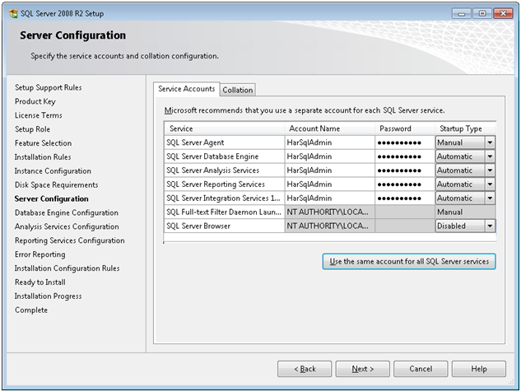

Figure - Server Configuration

1. Do the following in order to set up the execution account for the services.
   1. Enter the service account that MS SQL Server will be under
   2. Click “Use The Same Account For All SQL Server Services.”
   3. Click Next after your account settings have been configured.  
      The Database Engine Configuration window appears.

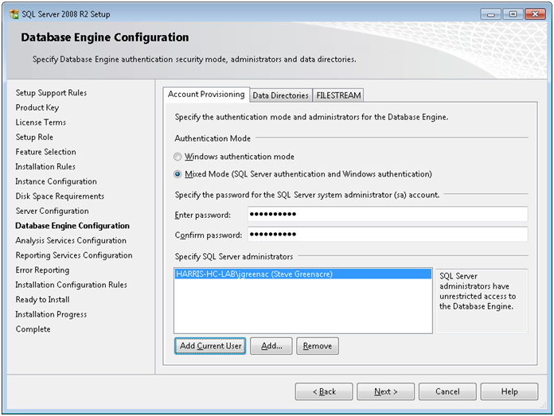

Figure - Database Engine Configuration

1. Do the following in order to set up the Database Engine Configuration:
   1. Make sure “Mixed Mode” authentication type is selected.
   2. Enter a password for the SQL Server System Administrator account (SA).
   3. Click “Add Current User” to specify yourself as an SQL Server Administrator.  
      **NOTE**: It is critical that you click this button to avoid Database Engine Configuration issues from arising later.
   4. Click Next.   
      The Analysis Services Configuration window appears.

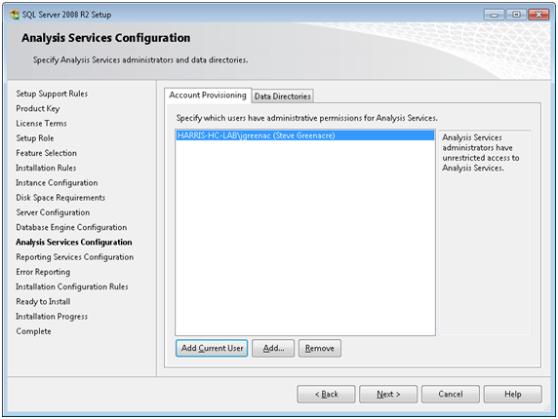

Figure - Analysis Services Configuration

1. Click “Add Current User” and then click Next.  
   The Reporting Services Configuration window appears.

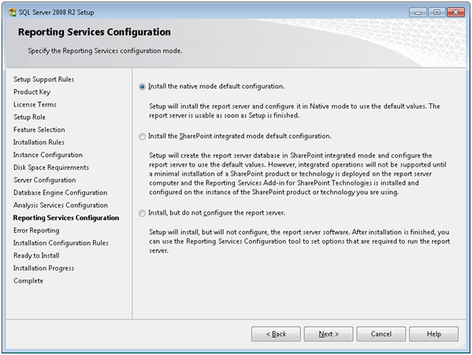

Figure - Reporting Services Configuration

1. Make sure that “Install the native mode default configuration” is selected, and then click Next.  
   The Error Reporting window appears.

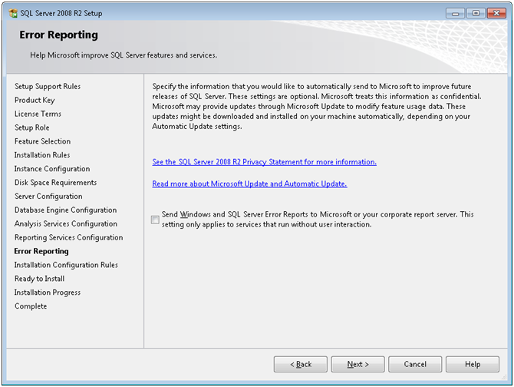

Figure - Error Reporting

1. Click Next.  
   The Installation Configuration Rules window appears.

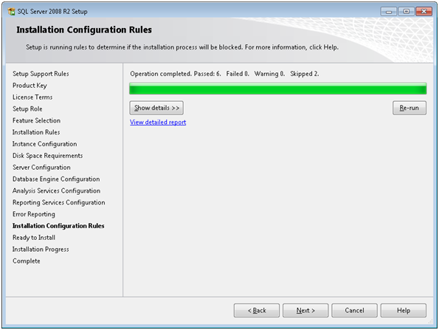

Figure - Installation Configuration Rules

1. Make sure this window shows all items as passed, no items as failed, and two items as skipped.

* The first skipped item is the “Instance name.” Keep in mind that in step 14, the default instance was selected.
* The second skipped item is the SQL Server 2000 Analysis Services. This item is not required because SQL 2008 analysis services are being installed.

1. Click Next.  
   The Ready to Install window appears.

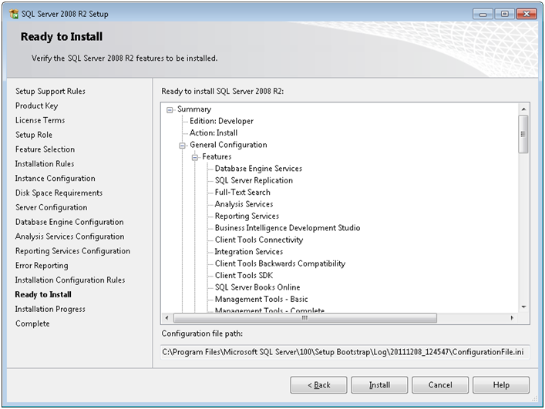

Figure - Ready to Install

1. Click Install.  
   The Installation Progress window appears.

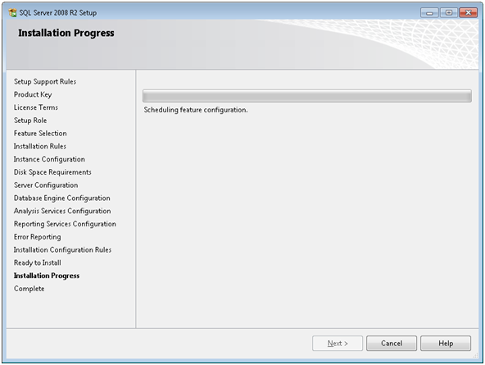

Figure - Installation Progress

1. Wait for the installation to complete.  
   When completed, the Complete window appears.

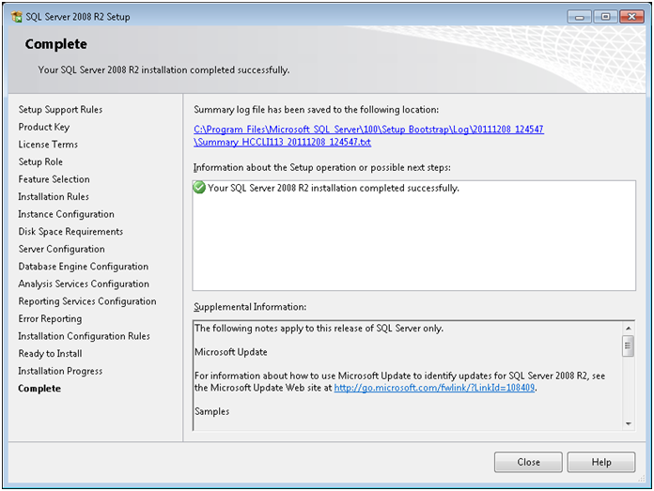

Figure - Complete

1. Click Close.  
   The Complete window closes, and the SQL Installation Center window should be onscreen.

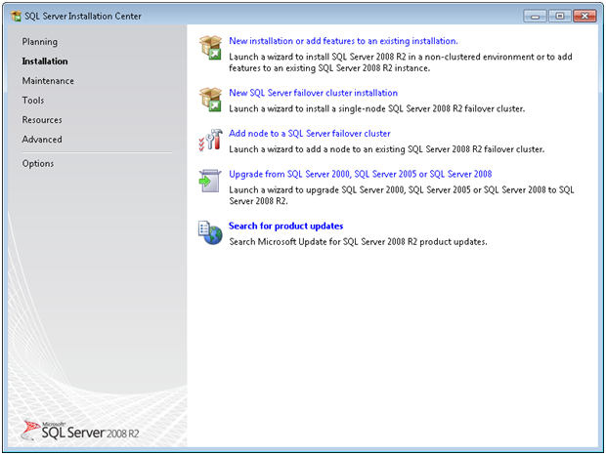

Figure - SQL Installation Center

1. Close the SQL Installation Center window.  
   The installation is complete.
2. Enable TCP/IP via the SQL Configuration Tool.

### After the Installation

After the installation is complete, perform the following steps.

1. Reboot the VM using the following command: Shutdown -r -t 0  
   The VM reboots.
2. Log in to SQL after the VM reboots, using your VM name as your server name as shown below.

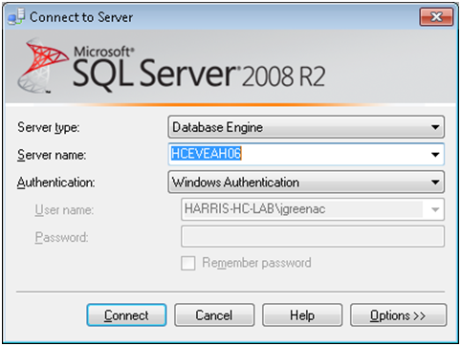

Figure - SQL Login

1. Run the following command via a query tool.  
   This will require a restart of the SQL Service.

USE Master  
GO  
EXEC sp_configure 'show advanced options', 1  
GO  
RECONFIGURE  
GO  
EXEC sp_configure 'xp_cmdshell', 1  
GO  
RECONFIGURE  
GO  
EXEC sp_configure 'clr enabled', '1'  
GO  
RECONFIGURE  
GO